 | ALL SAINTS’ COLLEGE  Ewing Avenue, Bull Creek, Western Australia
 | HUMAN BIOLOGY

Year 11 2007 Semester II Examination Question/Answer Booklet

C.C. STUDENT NUMBER - In figures 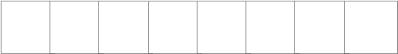

TIME ALLOWED FOR THIS PAPER
Reading time before commencing work: Ten minutes
Working time for paper: Three hours

MATERIALS REQUIRED/RECOMMENDED FOR THIS PAPER

TO BE PROVIDED BY THE TEACHER

This Question/Answer Booklet
Separate Multiple Choice Answer Sheet
Question Sheet for Part III

TO BE PROVIDED BY THE CANDIDATE

Standard items: Pens, pencils, eraser or correction fluid, ruler and highlighter.

Special Items: A 2B, B or HB pencil for the separate Multiple Choice Answer Sheet and calculators satisfying the conditions set by the Curriculum Council.

IMPORTANT NOTE TO CANDIDATES

No other items may be taken into the examination room.

It is your responsibility to ensure that you do not have any unauthorized notes or other items of a non-personal nature in the examination room. If you have any unauthorized material with you, hand it to the supervisor BEFORE reading any further.

STRUCTURE OF THIS PAPER

Part | No. of questions available | No. of questions to be attempted. | Marks available | Student’s Score
I Multiple choice | 40 | ALL | 80
II Diagram and short answer  questions | 8 | ALL | 80
III Extended answer questions: A  B | 2  2 | 1  1 | 20  20
Totals |  |  | 200

INSTRUCTIONS TO CANDIDATES

PART I Answer ALL questions, using a 2B, B or HB pencil, on the separate Multiple Choice Answer Sheet. Do NOT use a ballpoint or ink pen.

PART II Should be answered in this Question/Answer Booklet. Write your answers in the spaces provided, using a blue or black ballpoint or ink pen. Draw any diagrams in pencil.

PART III Should be answered in this Question/Answer Booklet. Answer on the pages following the end of questions, using a blue or black ballpoint or ink pen. Draw any diagrams in pencil.

PART I (80 marks)

Mark your answers to Questions 1-40 on the SEPARATE MULTIPLE CHOICE ANSWER SHEET, using a 2B, B or HB pencil. If you make an error, follow the instructions given to you on the answer sheet.

SELECT THE SINGLE CORRECT ALTERNATIVE IN EACH OF THE FOLLOWING QUESTIONS

Use the diagram below to answer Question 1

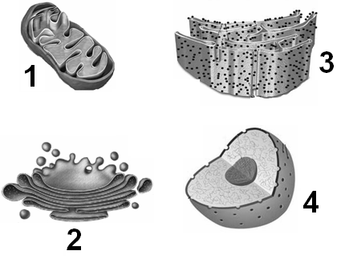

- Which of the following cell organelles above contains the enzymes needed to synthesize adenosine triphosphate in the presence of oxygen?

  - 1
  - 2
  - 3
  - 4

- The net flow of water molecules into or out of the cell during osmosis depends upon differences in the

- concentration of water molecules inside and outside the cell.
- rate of movement of insoluble molecules inside the cell.
- concentration of enzymes on either side of the cell membrane.
- concentration of solutes inside the cell.

- The protein chymotrypsin is derived from a parent molecule, chymotrypsinogen. Chymotrypsin is synthesised in the pancreas. Cell organelles that are essential for the production of chymotrypsin include

- vacuoles.
- golgi apparatus.
- cell membrane.
- ribosomes.

- Which cellular substances are produced anaerobically?

- Lactic acid and ADP.
- Carbon dioxide, water and ATP.
- Lactic acid and ATP.
- Lactic acid and carbon dioxide.

Use the diagram below to answer Question 5

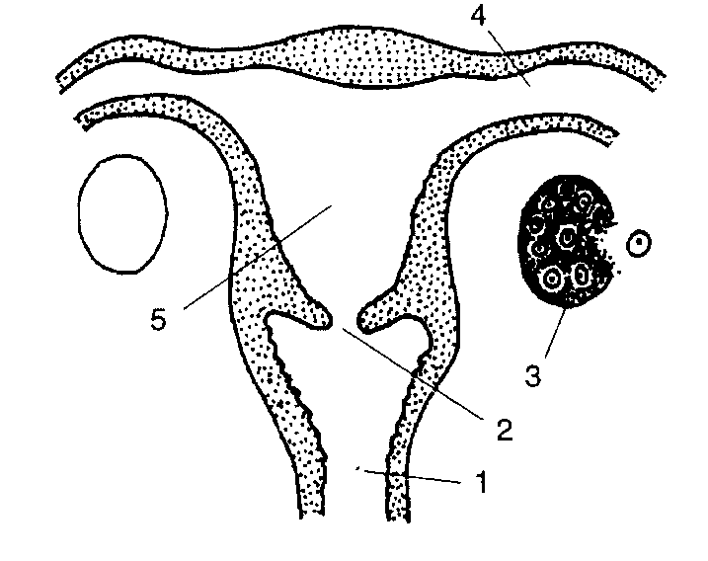

- Fertilisation and embryonic development normally occur in structures

- 1 and 5
- 2 and 4
- 3 and 1
- 4 and 5

- The cellular division process of meiosis in males usually produces

- only one diploid cell.
- four diploid cells.
- always two haploid cells
(d) four haploid cells

- Which one of the following applies to the early stages of both ovum and sperm production?

- Chromosomal pairing
- Polar body Formation
- Unequal division of the cytoplasm
- Spindle formation

Use the table below to answer Question 8

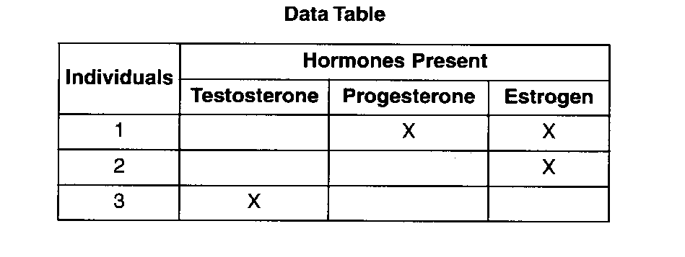

- The information in the table above indicates the presence of specific reproductive hormones in blood samples taken from three individuals. An X in the hormone column indicates a positive laboratory test for the appropriate levels necessary for normal reproductive functioning in that individual. Which processes could occur in individual 3?

- The production of ova only.
- The production of sperm and ova.
- The production of ova and embryonic development.
(d) The production of sperm only.

- Amniocentesis is usually performed

- around four months into pregnancy.
- after the baby is born.
- during the first trimester.
(d) any time during pregnancy.

- Scientific experiments revealed the following information about a certain molecule:

- It can be broken down into amino acids.
- It can break down proteins into amino acids
- It is found in high concentrations in the small intestine of humans.

This molecule is most likely a/an

- inorganic compound.
- enzyme.
- hormone.
- acid.

- Starch is a polysaccharide. Other polysaccharides synthesised by humans include

- lactose.
- sucrose.
- glucose.
(d) glycogen.

- An experiment was carried out to examine the composition of blood after it had passed through different organs. Results from one organ showed an increase in both carbon dioxide and nutrient levels but a decrease in oxygen levels after passing through the organ. Which organ would produce this result?

- Gall bladder.
- Kidney.
- Small Intestine.
(d) Pancreas.

Use the diagram below to answer Question 13

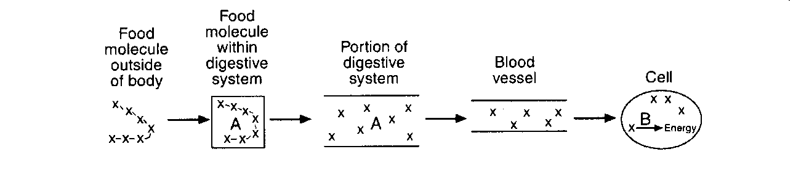

- Which one of the following best represents the chain of X’s and letters A and B?

X-X-X-X-X A and B

(a) Nutrient cellular wastes
(b) Nutrient enzymes
(c) Haemoglobin cellular wastes
(d) Haemoglobin hormones

- The lymphatic system contains

- valves in the lymph nodes.
- red blood cells.
- white blood cells.
(d) fluid that flows in blood directions.

Use the following diagram to answer question 15

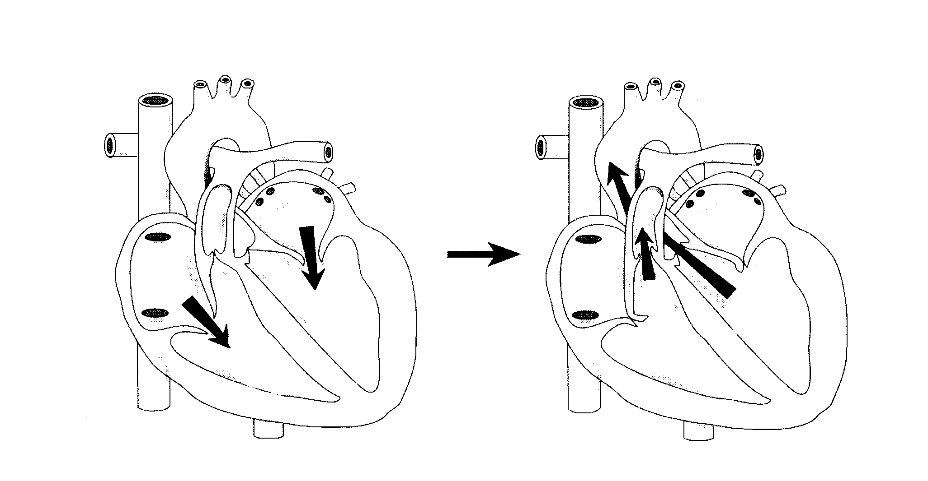

- The stages in the cardiac cycle shown by the diagrams above are atrial

- systole followed by ventricular systole.
- systole followed by ventricular diastole.
- diastole followed by ventricular systole.
(d) diastole followed by ventricular diastole.

- Blood travels around the body through arteries, veins and capillaries. Which of the following correctly describes the structure and/or function of these different blood vessels?

 | Artery | Vein | Capillary
(a) | Always carries oxygenated blood | Always carries deoxygenated blood | Always carries waste products
(b) | Thick muscular walls | Thin walls with valves | Walls are one cell thick
(c) | Takes blood to the heart | Thick muscular walls | Takes blood to and from the heart
(d) | Carries blood under high pressure | Carries blood under different pressures | Thin walls with valves

- Which pair of compounds would be classified as inorganic?

  - Nucleic acids and minerals.
  - Proteins and water.
  - Water and salts.
  - Nucleic acids and proteins.

Use the graph below to answer Question 18

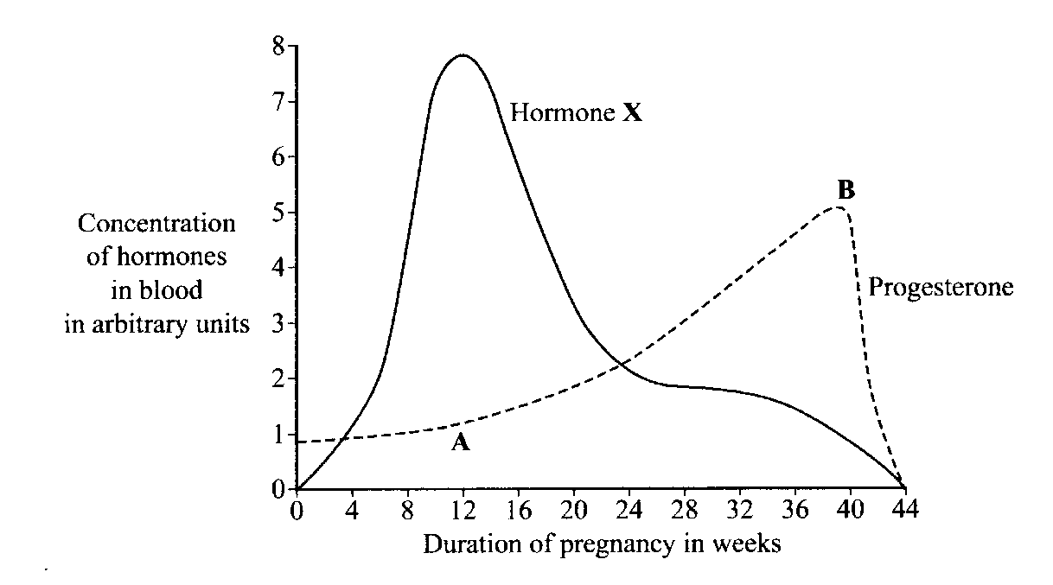

- Hormone X is

  - oestrogen.
  - human chorionic gonadotropin.
  - follicle stimulating hormone.
  - oxytocin.

- The concentration of progesterone increased from point A to point B. This is due to

- the development of the placenta.
- increased secretion by the corpus luteum.
- the chorion membrane becoming thicker.
- menstruation stopping.

- The attachment of a muscle at the movable end is termed the

- origin.
- extensor.
- insertion.
- flexor.

- Decreasing the angle of the elbow joint is an example of
- extension.
- abduction.
- flexion.
- adduction.

- The appendicular skeleton is composed of the bones making up the

  - vertebra, skull and pelvis.
  - vertebra, skull, ribs and sternum.
  - arms and legs and associated girdles.
  - arms and legs.

- Tendons have a very important role in the body. They

- join ligaments to bones.
- connect skeletal muscles to bone
- join bones to bones in synovial joints.
- absorb shock in the vertebra.

- The major extensor (muscle group) in the leg is the

  - quadriceps.
  - hamstrings.
  - anterior tibialis.
  - gastrocnemius.

Use the diagram below to answer Question 25
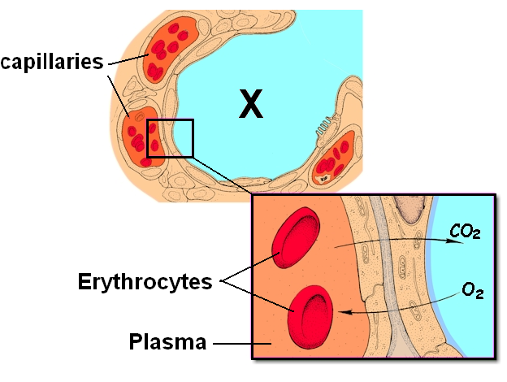

- X in the diagram above represents

  - an alveolus.
  - a lymph vessel.
  - a villus.
  - a bronchiole.

- What structure protects the body when a person swallows?

- Epiglottis
- Trachea
- Larynx
- Pharynx

- Which of the following shows the correct flow of blood around the body?

  - Left ventricle, left atrium, lungs, right ventricle, right atrium, tissues.
  - Left ventricle, tissues, lungs, right atrium, right ventricle, left atrium.
  - Left ventricle, lungs, right atrium, right ventricle, tissues, left atrium.
  - Left ventricle, tissues, right atrium, right ventricle, lungs, left atrium.

- Blood returning to the heart through veins is helped along by the action of

  - blood pressure and valves.
  - valves and contraction of muscles lining the walls of the vessels.
  - contraction of skeletal muscles and blood pressure.
  - valves and the contraction of skeletal muscles.

- Smoking increases the risk of cardiovascular disease (CVD). This occurs because

  - it decreases the oxygen carrying capacity of the haemoglobin.
  - the persons heart rate decreases.
  - the cells absorb less fat.
  - the blood pressure decreases (hypertension).

- A stroke is usually caused by

  - a build up of fatty arteries in the heart.
  - a blood clot in the brain.
  - the atherosclerosis of arteries in the body.
  - a high salt diet.

- The ‘milk let-down’ reflex involves the

  - hormones prolactin and oxytocin.
  - baby suckling on their mother’s breasts and releasing milk.
  - secretion of oxytocin to produce breast milk.
  - secretion of colostrum during breastfeeding.

- The ‘first’ significant feature of adolescence in males is

  - an increase in height.
  - an increase in muscle mass.
  - the growth of pubic hair and an enlargement of the penis.
  - the production and ejaculation of sperm.

- Menopause in females causes several physical changes due to decreased secretion of the sex hormones. This includes

  - irregular periods, hot flushes and an increase in the size of breast tissue.
  - hot flushes and skin problems.
  - the atrophy of the ovaries and breast tissue.
  - irregular periods, a thicker endometrium and decrease in the size of the ovaries.

- Primates are classified into two major groups. These are called the

  - Platyrrhines and Catarrhines.
  - Prosimii and Anthropoidea
  - Prosimii and Hominoidea
  - Ceboidea and Anthropoidea.

- One main characteristic of primates is the forward facing eyes. This allows

  - the distinguishing the colours of fruit and other food.
  - the judging of depth.
  - an increase in the field of view.
  - objects to be viewed two-dimensionally.

- One significant adaptation of the pongid family includes

  - a broad and shallow pelvis.
  - S-shaped vertebrae column.
  - U-shaped dentition.
  - non-opposable first digit on the hind limbs.

- A significant evolutionary trend in primates would be

  - the development of claws of most limbs.
  - a prehensile tail.
  - bipedal locomotion.
  - a general decrease in size.

- An animal was observed recently in a previously unexplored part of Africa. It was found to have a tail, semi-erect posture, a diastema and shorter hind limbs when compared to the arms. You should initially classify it, until further research could be done, as a

- Hominoid.
- Hominid.
- Pongid.
- Catarrhine.

- Old World Monkeys

  - have two premolars.
  - tend to be nocturnal.
  - are arboreal.
  - have a prehensile tail.

Use the diagram below to answer Question 40

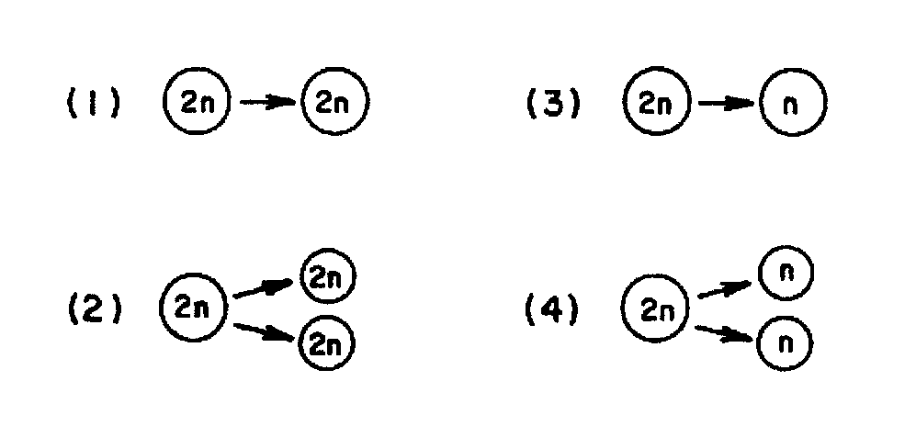

- Which diagram above correctly represents the process of mitosis?

  - 1
  - 2
  - 3
  - 4

END OF PART I

PART II (80 marks)
Write answers to ALL questions on the ruled lines after each question or in the spaces provided within each table. Write your answers in blue or black ballpoint or ink pen.

QUESTION 41 (Total 11 marks)

The diagram below shows the skeletons of two primates.
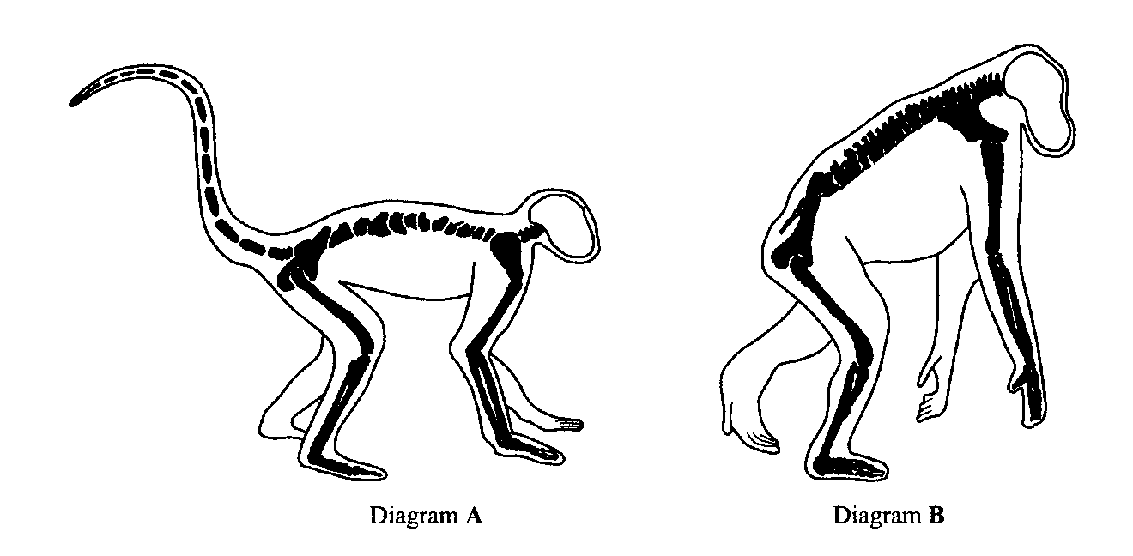

(a) Name ONE characteristic of primates that has not been shown in the diagram.

________________________________________________________________________________

________________________________________________________________________________

(1 mark)

(b) The primate in diagram B is more closely related to humans than the primate in diagram A. Describe ONE feature shown in the diagram that illustrates this observation.

________________________________________________________________________________

________________________________________________________________________________

________________________________________________________________________________

(1 mark)

(c) Name and describe TWO features of the primate in Diagram B that clearly distinguishes it from humans.

________________________________________________________________________________

________________________________________________________________________________

________________________________________________________________________________

________________________________________________________________________________

________________________________________________________________________________

(4 marks)

(d) Humans also possess ‘special’ features or adaptations that clearly distinguish them as a group of primates. Select and describe FIVE skeletal adaptations of humans.

________________________________________________________________________________

________________________________________________________________________________

________________________________________________________________________________

________________________________________________________________________________

________________________________________________________________________________

________________________________________________________________________________

________________________________________________________________________________

________________________________________________________________________________

________________________________________________________________________________
________________________________________________________________________________
________________________________________________________________________________

________________________________________________________________________________

________________________________________________________________________________
________________________________________________________________________________

(5 marks)

QUESTION 42 (Total 10 marks)

Skeletal muscle and the muscle type shown in the diagram below have several similarities in the way they function as well as some differences.

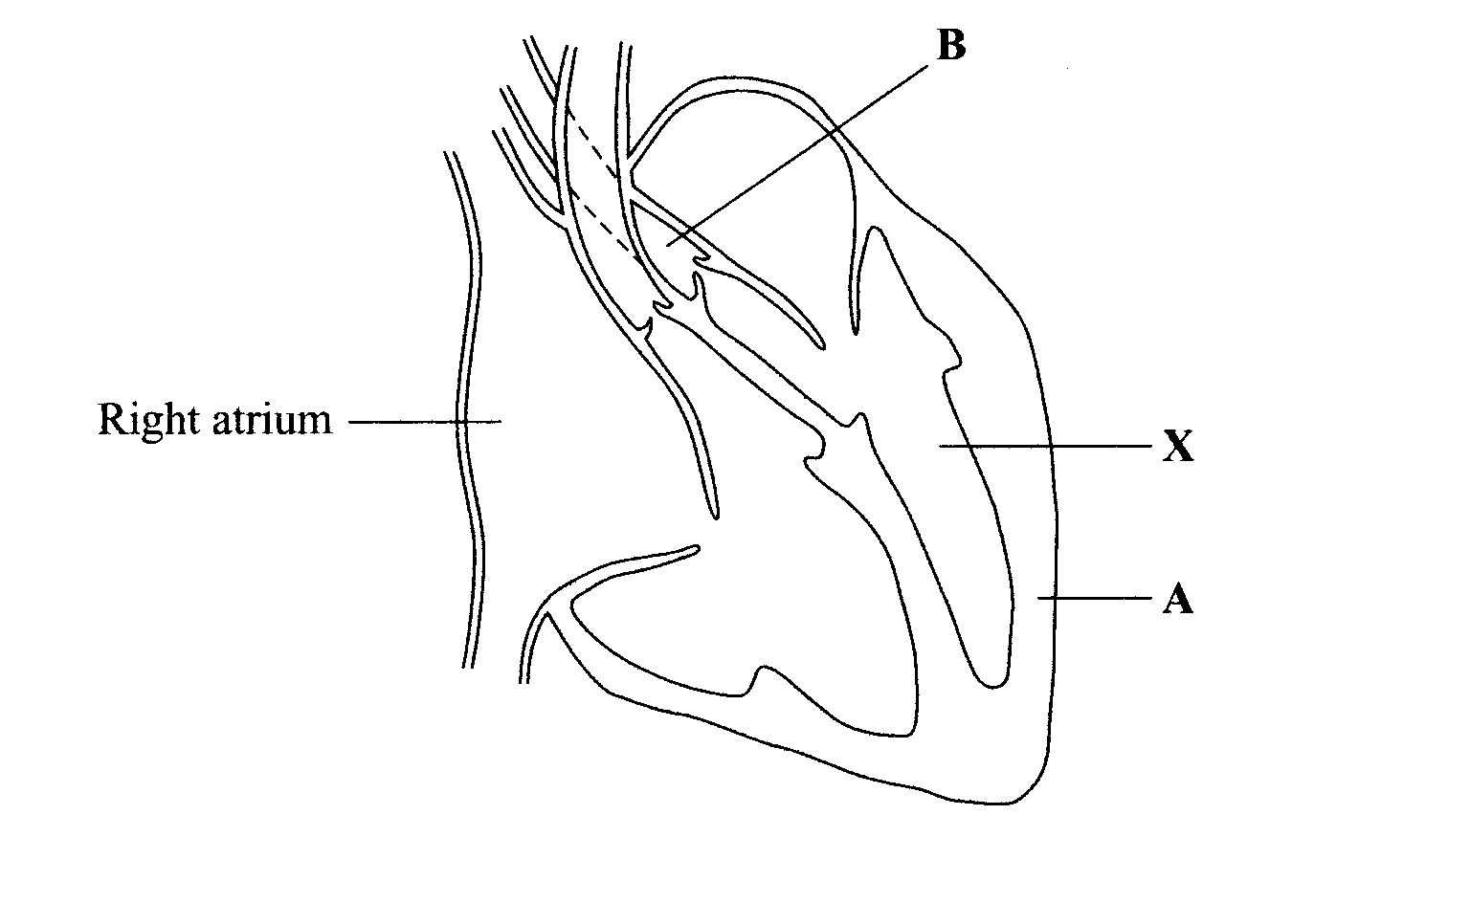

(a) Name the muscle type shown in the diagram above. _______________________________

(1 mark)

(b) Describe ONE of the similarities in the way skeletal and the muscle shown above function.

________________________________________________________________________________________________________________________________________________________________________________________________________________________________________________
(1 mark)

(c) Describe TWO ways in which the functioning of the muscle shown above is different to that of skeletal muscle.

________________________________________________________________________________
________________________________________________________________________________
________________________________________________________________________________
________________________________________________________________________________
(2 marks)

Use the graph below to answer question 42(d) to (f)

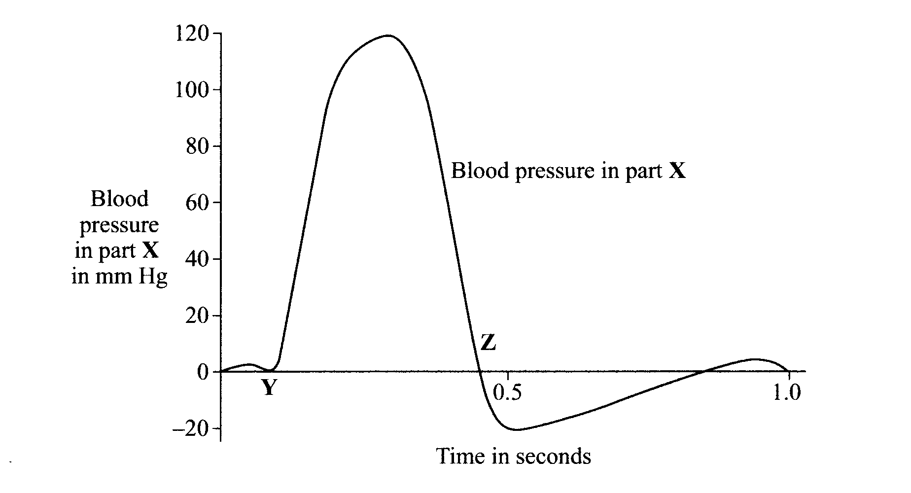

(d) Explain how the action of structure A and the role of structure B in the diagram on the previous page are related to the pressure changes between points Y and Z on the graph above.

________________________________________________________________________________
________________________________________________________________________________________________________________________________________________________________________________________________________________________________________________
(2 marks)

A ‘high fat’ diet may cause an extra layer to form on the inside of structure B.

(e) What is the name of structure B? __________________________________ (1 mark)

(f) Explain the effect that an extra layer of fat in structure B would have on the blood pressure shown in the graph above.

________________________________________________________________________________________________________________________________________________________________________________________________________________________________________________________________________________________________________________________________________________________________________________________________________________

(3 marks)

QUESTION 43 (Total 9 marks)

The diagram below shows the way in which breathing occurs in humans.

Relaxation of the diaphragm and intercostal muscles
Contraction of the diaphragm and intercostal muscles.

Brain

B

A

(a) What breathing term (inspiration or expiration) does A represent? _____________________

(1 mark)

(b) The intercostal muscles are found between the ribs. Under normal breathing conditions, describe the role of the intercostal muscles during B.

________________________________________________________________________________________________________________________________________________________________________________________________________________________________________________________________________________________________________________________________
(2 marks)

(c) Describe how the air pressure is changed in the thoracic cavity during B and the overall effect this has on breathing.

________________________________________________________________________________________________________________________________________________________________________________________________________________________________________________________________________________________________________________________________________________________________________________________________________________ (3 marks)
(d) Describe how the following respiratory system components or actions assist in normal breathing or lung function.

Component of the Respiratory System | Function
Cilia
Mucus Secretion
Coughing

(3 marks)

QUESTION 44 (Total 10marks)

Explain the difference between EACH of the following pairs of terms:

(a) physical and chemical digestion

________________________________________________________________________________________________________________________________________________________________________________________________________________________________________________
(2 marks)
(b) peristalsis and segmentation

________________________________________________________________________________________________________________________________________________________________________________________________________________________________________________
(2 marks)
(c) lacteal and villus
________________________________________________________________________________________________________________________________________________________________________________________________________________________________________________
(2 marks)
(d) bolus and chyme

________________________________________________________________________________________________________________________________________________________________________________________________________________________________________________
(2 marks)
(e) glands and enzymes

________________________________________________________________________________________________________________________________________________________________
(2 marks)

QUESTION 45 (Total 13 marks)

A student investigated the stages of mitosis using an ‘onion-root tip’. She placed the onion root tip sample on a microscope slide, stained it and placed a cover slip over the stained sample.

(a) Explain why the onion root tip sample was stained.

________________________________________________________________________________________________________________________________________________________________________________________________________________________________________________
(2 marks)

(b) The student counted 700 ‘onion-root tip’ cells using a magnification of 150x with a field of view 0.3 mm. She then changed the total magnification to 300x to count the mitotic cells. What would be the new field of view size in micrometers and how many cells would be counted? Show your working

(2 marks)

The table below lists the number of cells counted for each phase of mitosis by the student (at 300x magnification).

Stage | Number of cells
Telophase | 10
Anaphase | 15
Metaphase | 23
Prophase | 80
Interphase | 123

(c) What is the average number of cells in any stage? _______________________________

(1 mark)

(d) The mitotic phases have been incorrectly arranged in the table above. List the phases in the correct order.

____________________________________________________________________________________________________________________________________________________
(2 marks)

(e) During the phases of mitosis the chromosomes are clearly visible. Draw four chromosomes attached to a spindle fibre, as it would appear during metaphase in the space below. Label your diagram with the terms centromere, chromatid and spindle fibre.

(4 marks)

(f) Meiosis is another form of cellular division in the body. Describe TWO differences of meiosis when compared to mitosis.

________________________________________________________________________________
________________________________________________________________________________
________________________________________________________________________________
________________________________________________________________________________
________________________________________________________________________________
________________________________________________________________________________

(2 marks)

QUESTION 46 (Total 9 marks)

The graph below shows the blood levels of two hormones during one sexual cycle of a female. Ovarian structures produced over the same time period are shown below the graph.

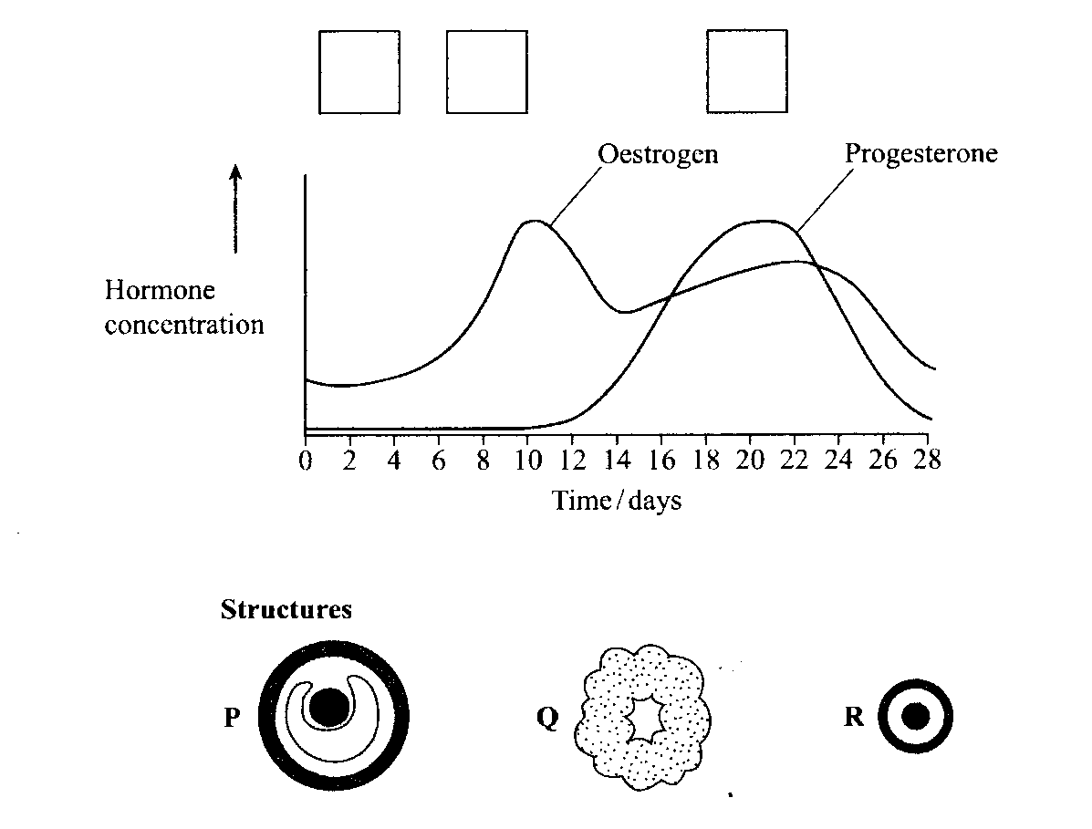

(a) Write the appropriate letters in the three boxes above the graph to show the order in which the ovarian structures appear during the cycle.
(3 marks)

(b) Name the hormone that causes structure Q to develop.

_____________________________________________________________________________

(1 mark)

(c) Which of the structures (P, Q or R) secretes progesterone?

_____________________________________________________________________________

(1 mark)

(d) Describe TWO effects of the hormone progesterone on the uterus.

_______________________________________________________________________________
_______________________________________________________________________________
_______________________________________________________________________________

(2 marks)

(e) Explain how oestrogen in contraceptive pills prevents fertilization from taking place.

________________________________________________________________________________
________________________________________________________________________________
________________________________________________________________________________

(2 marks)

QUESTION 47 (10 marks)
The diagram below shows the placenta and umbilical cord during pregnancy.

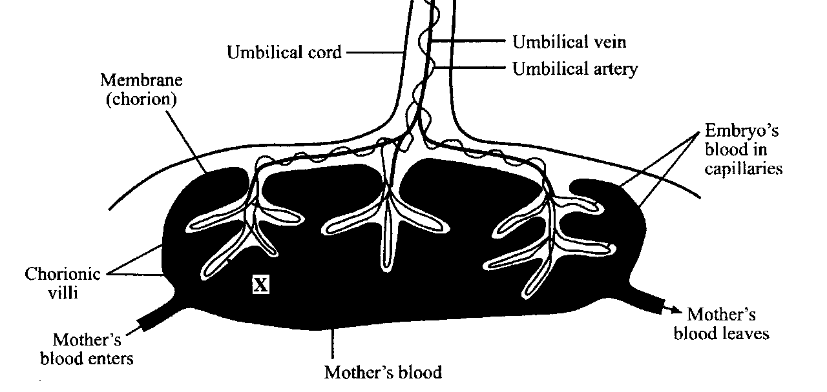

(a) Using an arrow, clearly show the direction of the blood flow in the umbilical vein.
(1 mark)
(b) Name TWO substances that pass in the direction of X.

____________________________________________________________________________
(2 mark)

(c) The amnion membrane develops first and surrounds the embryo. What fluid does this membrane secrete?

____________________________________________________________________________
(1 mark)

(d) Describe how the structure of the chorionic villi assists their function.

________________________________________________________________________________________________________________________________________________________________________________________________________________________________________________
(2 marks)

In a recent study on smoking and pregnancy, it was found that heavy smokers that fell pregnant had a greater chance of multiple births (i.e. twins) than non-smokers.

(e) Describe how twins occur in humans.
________________________________________________________________________________________________________________________________________________________________________________________________________________________________________________
(2 marks)

(f) Describe why expectant mothers should not smoke or be exposed to passive smoking during pregnancy.
________________________________________________________________________________________________________________________________________________________________________________________________________________________________________________
(2 marks)

QUESTION 48 (Total 8 marks)

The following graphs show the heights of boys and girls between 6 and 18 years of age. The vertical bar represents the range of heights for a specific age.

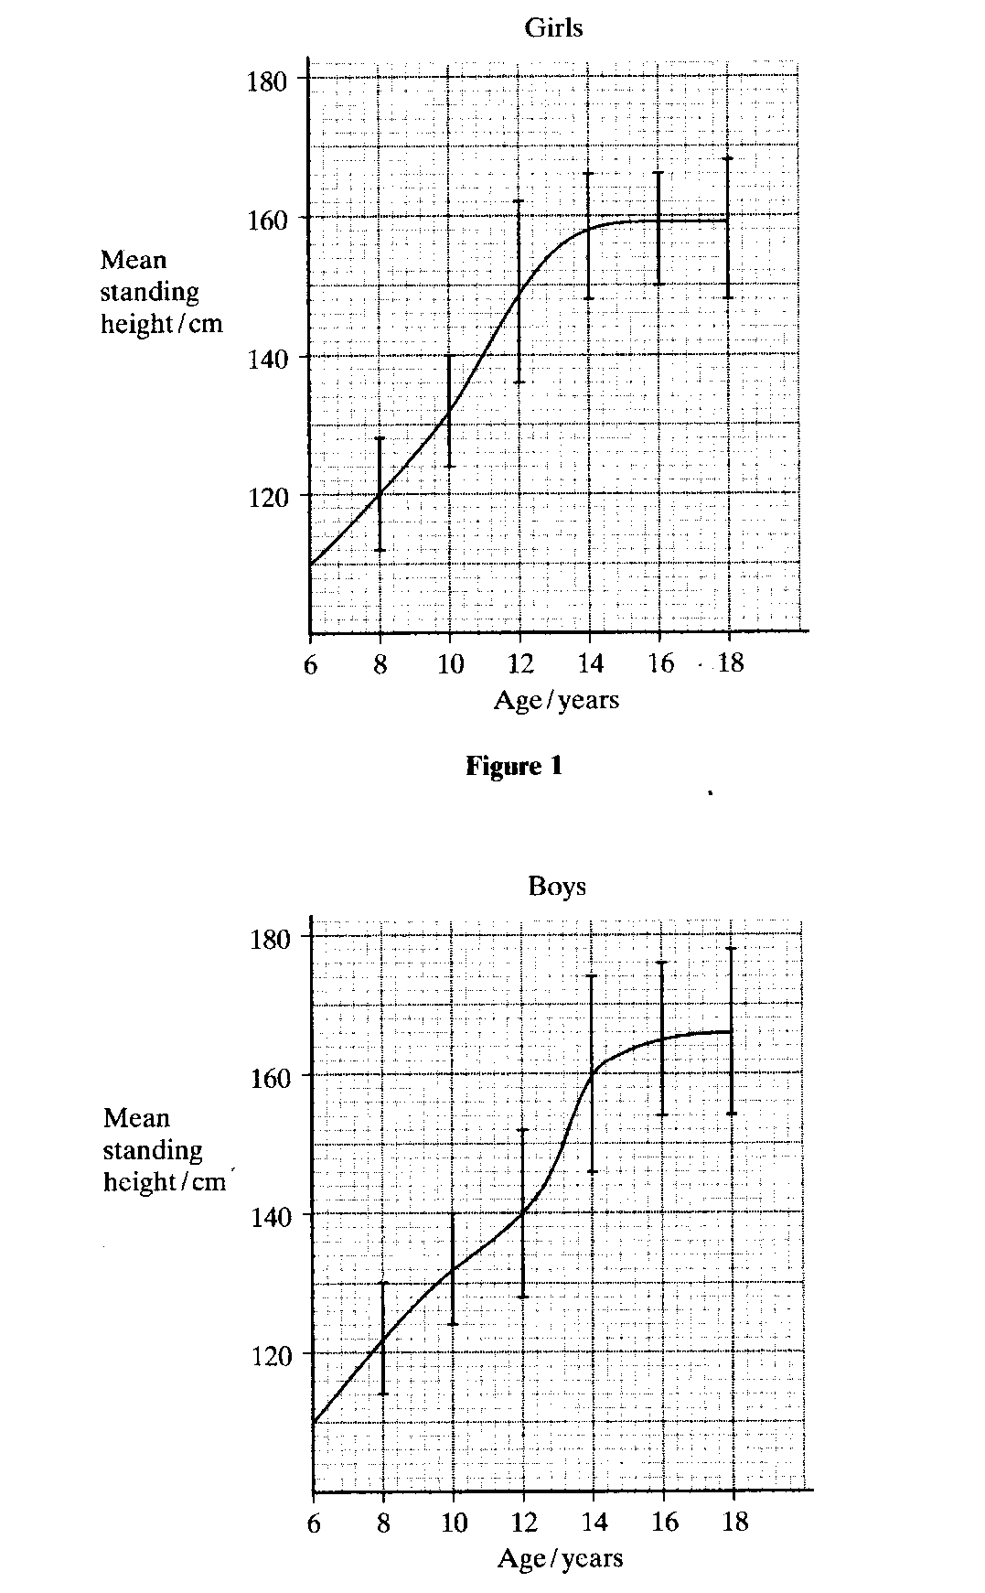

(a) At which age did the girls show the greatest variation in height? Give ONE reason.

________________________________________________________________________________________________________________________________________________________________________________________________________________________________________________
(2 marks)

(b) At which age did the boys experience the greatest increase in height for a two-year period?

________________________________________________________________________________

(1 mark)

(c) What causes this increase in height to occur in both boys and girls?

________________________________________________________________________________________________________________________________________________________________________________________________________________________________________________
(2 marks)

(d) What other changes occur in boys during the ages of 12 to 18 years?

________________________________________________________________________________________________________________________________________________________________________________________________________________________________________________
________________________________________________________________________________________________________________________________________________________________________________________________________________________________________________

(3 marks)

END OF PART II

PART III (40 marks)

Answer ONE question from SECTION A and ONE question from SECTION B. Illustrate your answers with diagrams where appropriate. Up to TWO MARKS may be deducted for poorly structured answers: that is, answers in point form or diagrams not explained in the text of your answers. DO NOT WRITE ANSWERS IN PENCIL. Write your answers on the lined pages in your Question / Answer Booklet following the end of questions.

SECTION A.

ANSWER EITHER QUESTION 49 OR QUESTION 50 – NOT BOTH

QUESTION 49 (Total 20 Marks)

(a) Explain the structural differences between an arteries and veins. Cardio-vascular diseases affect the functioning of arteries. Explain the difference between Arteriosclerosis and Atherosclerosis. Explain how a Coronary Bypass is used to treat the latter of the two diseases in the Heart.

(8 marks)

(b) Enzymes are found throughout the body and enhance cellular function especially in the digestive system. Describe the role of the THREE main types of digestive enzymes found in the body and give examples for each type. Also include their site of action and products. (12 marks)

OR

QUESTION 50 (Total 20 Marks)
(a) What is ‘expired air resuscitation (EAR)’? How is ‘EAR’ different to cardiopulmonary resuscitation (CPR)?
(10 marks)

(b) The skeletal system is composed of bones and joints. What is a joint? Describe the THREE different types of joints found in the body and the range of movement for each one. Give one example of each type of joint.
(10 marks)

SECTION B

ANSWER EITHER QUESTION 51 OR QUESTION 52 – NOT BOTH

QUESTION 51 (Total 20 Marks)

    - Breastfeeding is recommended for all newborn babies; however, in some cases the newborn baby has to be bottle-fed. Describe FIVE advantages for each method of providing nourishment to a newborn baby.
(10 marks)

b) After a baby is born, significant changes occur to both the mother and baby. Describe the changes that occur to the mother and baby.
(10 marks)
OR

QUESTION 52 (Total 20 Marks)

- Pregnancy can be prevented using various contraceptive devices. Select FIVE different types of contraception and discuss how each type of contraceptive device works and any side effects or disadvantages.
(10 marks)

- What are fertilization and implantation? Describe where and when these two processes occur in the body and discuss the importance of fertilization and implantation in producing human ‘off-spring.’
(10 marks)

END OF PAPER

